Objectives
LAB 02
Operators, Control Statements, Loops and Arrays

To learn about the Operators, If Statement, Switch Statement, Loops and Arrays in Java

Operators in Java

Operator in Java is a symbol which is used to perform operations. For example: +, -, *, / etc. There are many types of operators in Java which are given below:
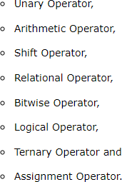

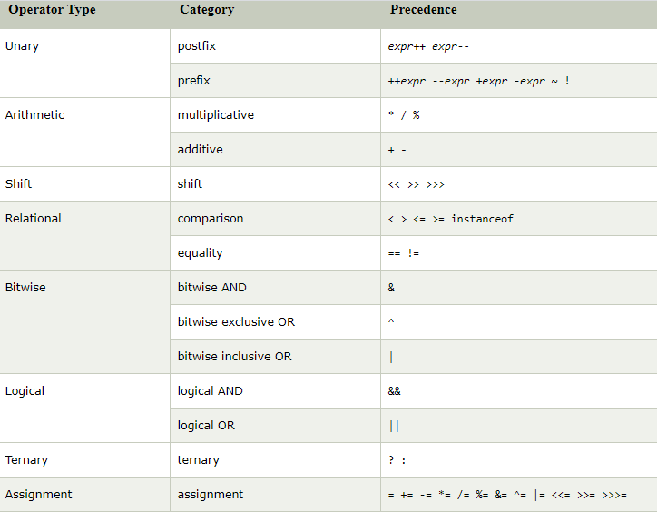
Java Operators Precedence

Java Ternary Operator

Java Ternary operator is used as one liner replacement for if-then-else statement and used a lot in Java programming. it is the only conditional operator which takes three operands.

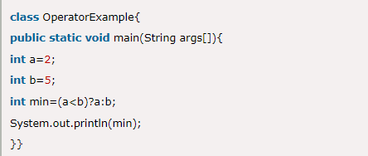
Java Ternary Operator Example Example 01:

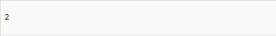
Output:

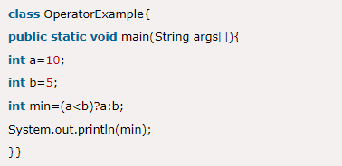
Example 02:
Output:
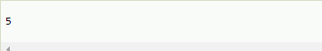

Java If-else Statement

The Java if statement is used to test the condition. It checks boolean condition: true or false. There are various types of if statement in Java.

- if statement
- if-else statement
- if-else-if ladder
- nested if statement

Java if Statement
The Java if statement tests the condition. It executes the if block if condition is true.

Syntax:

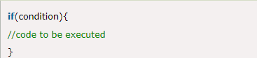

Flow Diagram:
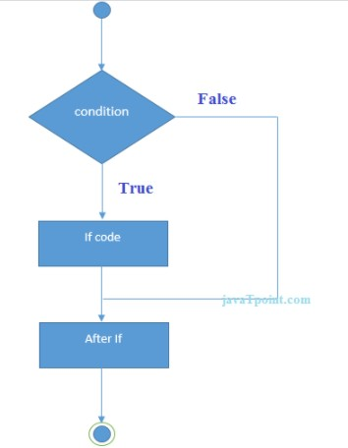

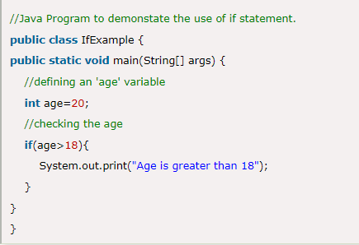
Example 03:
Output:

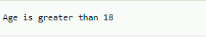

Java if-else Statement
The Java if-else statement also tests the condition. It executes the if block if condition is true otherwise else block is executed.

Syntax:
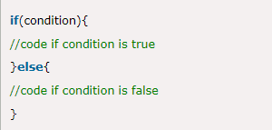

Flow Diagram:

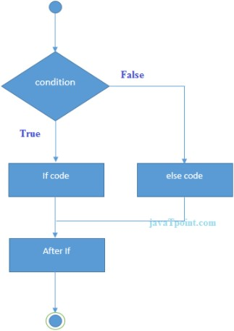

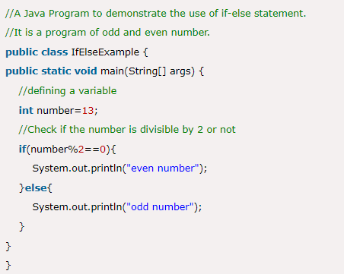
Example 04:
Output:


Java if-else-if Statement
The if-else-if ladder statement executes one condition from multiple statements.

Syntax:
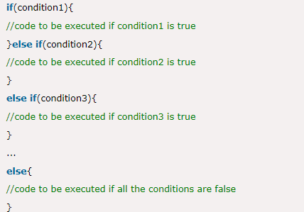

Example 05:
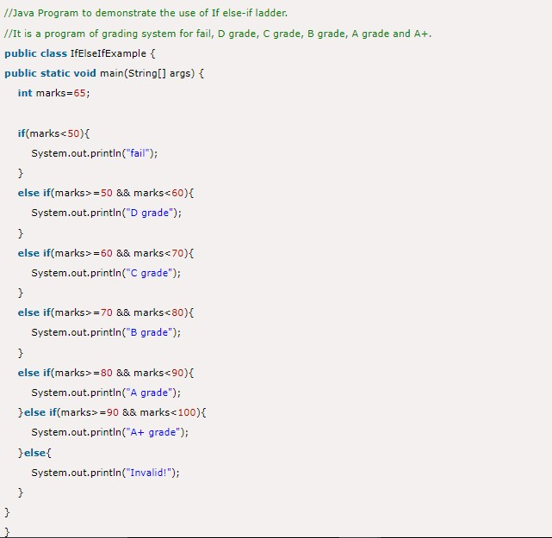

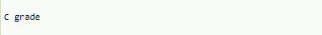
Output:

Java Switch Statement

The Java switch statement executes one statement from multiple conditions. It is
like if-else-if ladder statement. In other words, the switch statement tests the equality of a variable against multiple values.

Points to Remember

- There can be one or N number of case values for a switch expression.
- The case value must be of switch expression type only. The case value must be literal or constant. It doesn't allow variables.
- The case values must be unique. In case of duplicate value, it renders compile- time error.
- The Java switch expression must be of byte, short, int and string.
- Each case statement can have a break statement which is optional. When control reaches to the break statement, it jumps the control after the switch expression. If a break statement is not found, it executes the next case.
- The case value can have a default label which is optional.

Syntax:
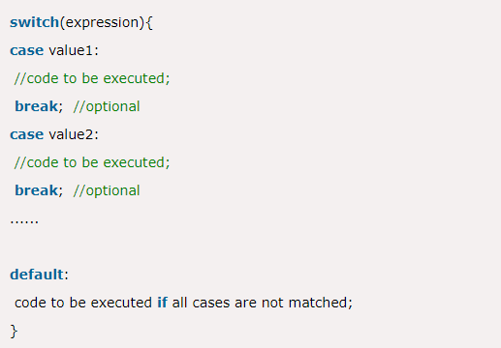

Flow Diagram:
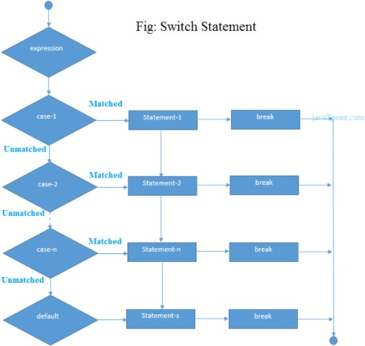

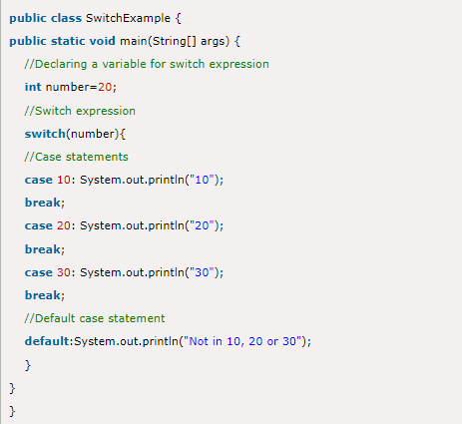

Output:

Java Switch Statement is fall-through

The Java switch statement is fall-through. It means it executes all statements after the first match if a break statement is not present.

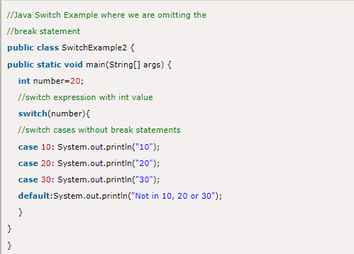

Output
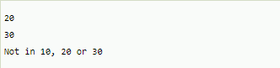

Java Switch Statement with String

Java allows us to use strings in switch expression since Java SE 7. The case statement should be string literal.

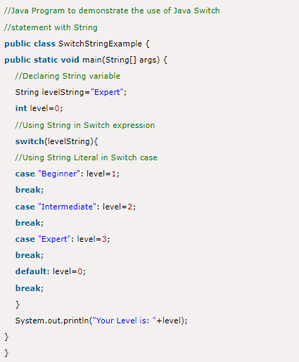
Example 08:

Output
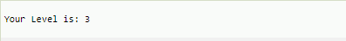

Loops in Java

In programming languages, loops are used to execute a set of instructions/functions repeatedly when some conditions become true. There are four types of loops in Java.

- for loop
- for-each loop
- while loop
- do-while loop

Java For Loop

The Java for loop is used to iterate a part of the program several times. If the number of iteration is fixed, it is recommended to use for loop.

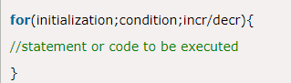
Syntax:

Flow Diagram:

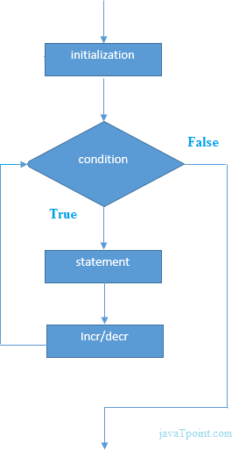

Example 09:
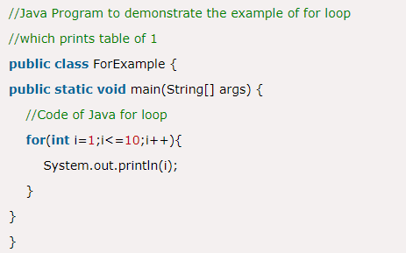

Output
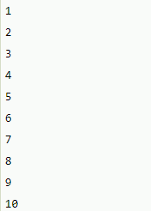

Java for-each Loop

The for-each loop is used to traverse array or collection in java. It is easier to use than simple for loop because we don't need to increment value and use subscript notation.

It works on elements basis not index. It returns element one by one in the defined variable.

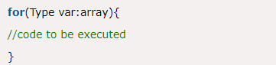

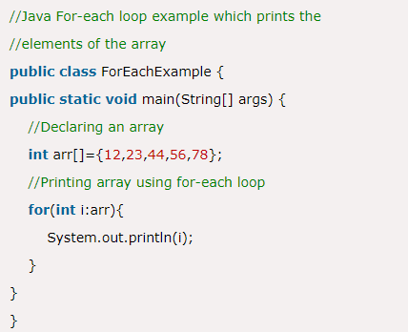
Example 10:
Output
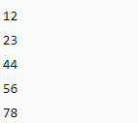

Java While Loop

The Java while loop is used to iterate a part of the program several times. If the number of iteration is not fixed, it is recommended to use while loop.

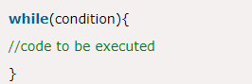

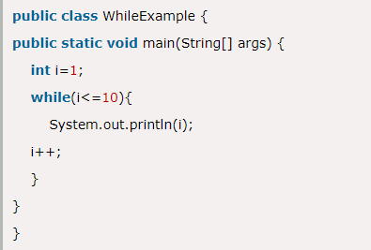
Example 11:

Output
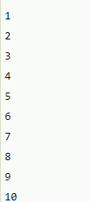

Java do-While Loop

The Java do-while loop is used to iterate a part of the program several times. If the number of iteration is not fixed and you must have to execute the loop at least once, it is recommended to use do-while loop.

The Java do-while loop is executed at least once because condition is checked after loop body.

.Syntax:
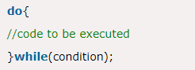

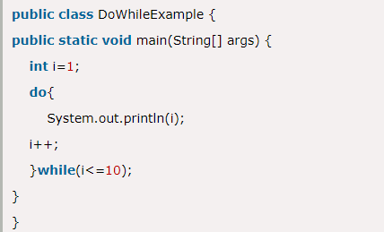
Example 12:
Output
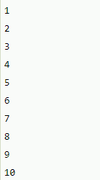

Java Arrays
Java array is an object which contains elements of a similar data type. Additionally, The elements of an array are stored in a contiguous memory location. It is a data structure where we store similar elements. We can store only a fixed set of elements in a Java array.
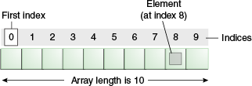
Array in Java is index-based, the first element of the array is stored at the 0th index, 2nd element is stored on 1st index and so on.

Types of Array in java
There are two types of array.
- Single Dimensional Array
- Multidimensional Array

Single Dimensional Array in Java

Syntax to Declare an Array in Java
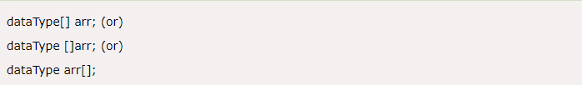

Instantiation of an Array in Java
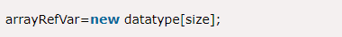

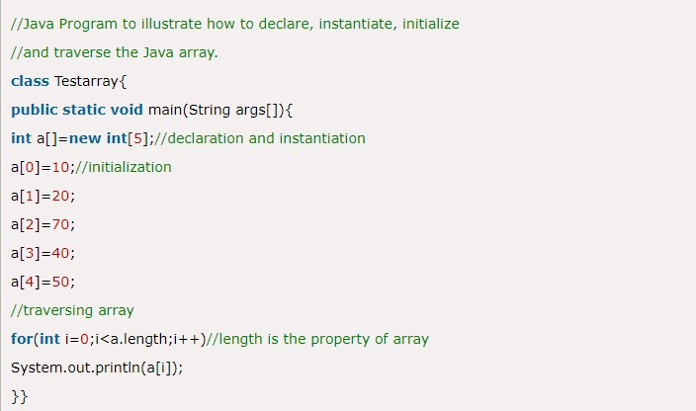

Output
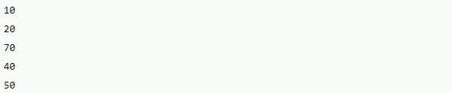

Declaration, Instantiation and Initialization of Java Array

We can declare, instantiate and initialize the java array together by:

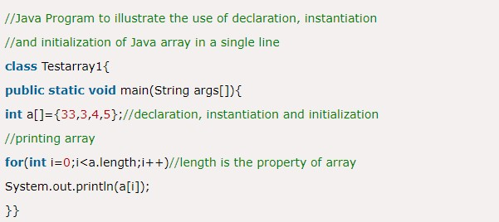

Output
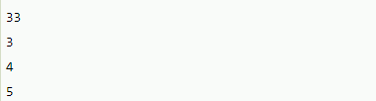

For-each Loop for Java Array

We can also print the Java array using for-each loop. The Java for-each loop prints the array elements one by one. It holds an array element in a variable, then executes the body of the loop.

Syntax:
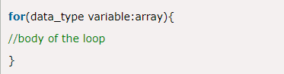

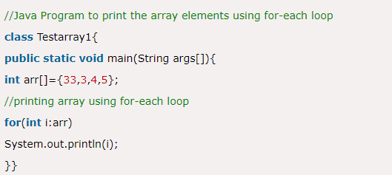

Output
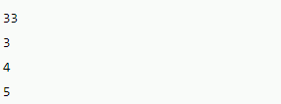

Multidimensional Array in Java

In such case, data is stored in row and column based index (also known as matrix form).

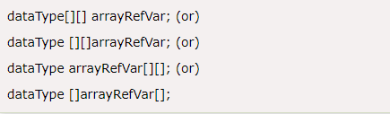
Syntax:

Example to instantiate Multidimensional Array in Java

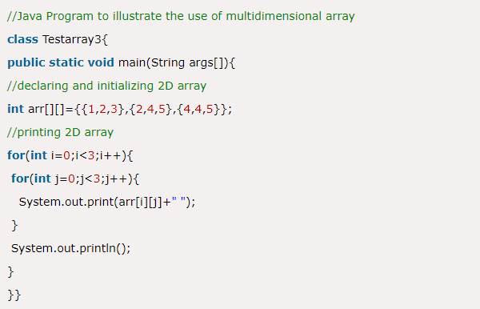
Example 16:
Output
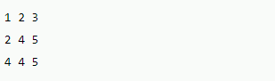

Task 01:
Write a Java program to find the number of days in a month.

Test Data:
Input a month number: 2 Input a year: 2016

Expected Output:
February 2016 has 29 days

Assignment 02

Problem 01:
Write a Java program that takes the user to provide a single character from the alphabet. Print Vowel or Consonant, depending on the user input. If the user input is not a letter (between a and z or A and Z), or is a string of length > 1, print an error message.

Test Data:
Input an alphabet: p

Expected Output:
Input letter is Consonant

Problem 02:
Write a Java program to find the largest of three numbers.

Test Data:
Input the 1st Number: 25 Input the 2nd Number: 63 Input the 3rd Number: 10 Expected Output:
The 2nd Number is the greatest among three

Problem 03:
Write a program to print following:
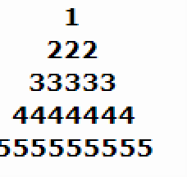
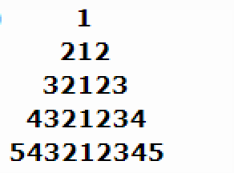

Submission Instructions
- Name your Files as P1,P2, etc. ( example : P1.java)
- Name your home assignment as Lab_0X .java (X is the lab number)
- Create a new folder named CS231abc where abc is your 3 digit roll #. e.g. CS231125.

- Copy all the task and assignment files into this folder.
- Now make a zip file of above made folder named CS231125abc.zip is created e.g. CS231125.zip
- Upload this zipped folder on LMS under the assignment named Lab 0X_Assignment.

